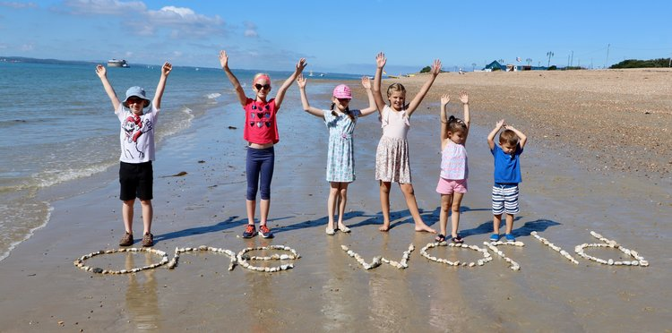
The ONE WORLD song
As part of the BBC Music Day 2018 The Portsmouth Music Hub has produced a film of its 50 choirs and 2,500 singers singing the One World Song. They are very happy for us to adopt it as our song for One World Week and share it.
It fits our theme “The world is changing – how about us?” very aptly. Do watch – it’s great. Perfect for us. They say we are welcome to share it and use it. So, do pass the link on to schools, choirs etc.
It would make a great introduction (or send off) for an event or a school assembly - it’s guaranteed to make you smile! The lyrics are there too so people can join in the singing.
Find it on youtube here: https://www.youtube.com/watch?v=eqch4JXbJd8&feature=youtu.be
You can find the lyrics and backing tracks plus lots of other environmental songs on the Portsmouth Music hub website under One World. http://www.portsmouthmusichub.org/one-world/
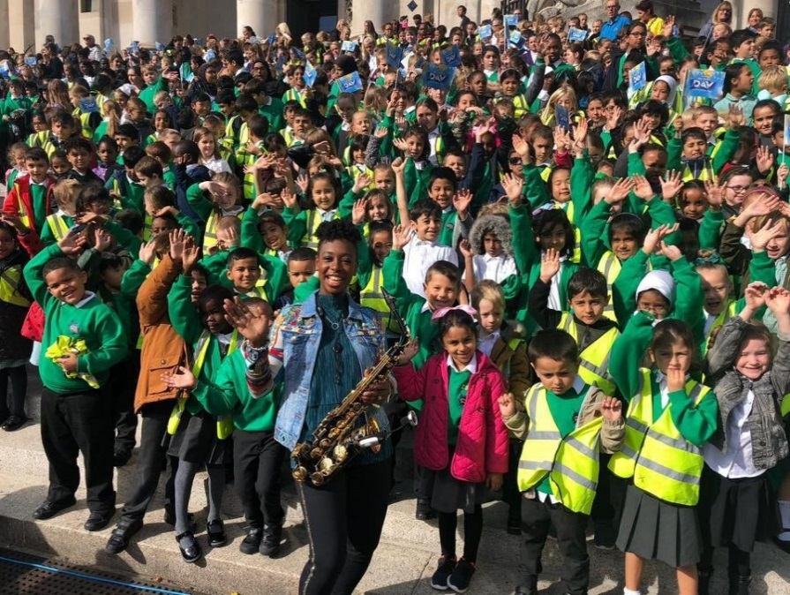
Part of the assembled choirs on the steps of Portsmouth’s Guildhall on Sept 28th 2018

(Photos from the Portsmouth Music Hub)

